Cloud Security Posture Management (CSPM) Compliance Dashboard

MS Cybersecurity Capstone Project - Initial Report

Kwaku Gyamfi Boamah
MS in Cybersecurity
May 2026
Contents
ABSTRACT 3
1. INTRODUCTION 4
1.1 Background and Context 4
1.2 The Problem Statement 4
1.3 Research Significance 5
2. MOTIVATION 5
2.1 Industry Need 5
2.2 Personal Motivation 5
2.3 Academic Contribution 6
3. OBJECTIVES 6
3.1 Primary Objective 6
3.2 Specific Technical Objectives 6
3.3 Measurable Success Criteria 7
4. METHODOLOGY 7
4.1 Development Approach 7
4.2 Technology Stack 8
4.3 System Architecture 8
4.4 Database Schema Design 9
4.5 Security Implementation 10
4.7 Testing Strategy 10
4.8 Data Collection 11
5. CONCEPT AND TOOL USAGE 12
5.1 What is CSPM? 12
5.2 The Need for CSPM Tools 12
5.3 Platform Use Cases 13
5.4 Key Platform Features 14
5.5 Platform Screenshots 15
6. CHALLENGES AND LIMITATIONS 20
6.1 Technical Challenges 20
6.2 Scope Limitations 21
6.3 Research Limitations 21
6.4 Future Work 21
7. CONCLUSION 22
8. REFERENCES 23

ABSTRACT
Cloud computing has become the backbone of modern enterprise infrastructure, with organizations migrating critical workloads to platforms like Amazon Web Services (AWS). However, this shift introduces complex security challenges and compliance requirements across multiple regulatory frameworks including Center for Internet Security (CIS) AWS Foundations, ISO 27001, NIST Cybersecurity Framework, and Payment Card Industry Data Security Standard (PCI-DSS). Traditional security tools often operate in silos, identifying individual vulnerabilities without understanding how they combine to create exploitable attack paths.
This capstone project presents a comprehensive Cloud Security Posture Management (CSPM) platform that goes beyond basic compliance checking by implementing an intelligent risk correlation engine. The system automatically scans AWS infrastructure using Prowler, maps findings to four major compliance frameworks, and employs a novel "Toxic Combinations" detection algorithm that identifies how multiple security gaps combine into critical attack scenarios. The platform provides actionable remediation guidance with AWS Command Line Interface (CLI) commands, Terraform configurations, and manual procedures, while generating executive-ready PDF reports with strategic security insights.
Built using a modern technology stack (React frontend, FastAPI backend, PostgreSQL database, Docker containerization), the platform demonstrates production-grade software engineering practices including multi-factor authentication, comprehensive audit logging, and RESTful API design. The system successfully processes 67-140 security findings per scan across six demonstration accounts, detecting 1-4 critical attack paths per environment with risk scores ranging from 76-95. This project bridges the gap between compliance automation and actionable security intelligence, providing security teams with prioritized, context-aware remediation strategies.
Keywords: Cloud Security, CSPM, Compliance Automation, Attack Path Analysis, AWS Security, Risk Correlation, Security Orchestration

1. INTRODUCTION

1.1 Background and Context
The rapid adoption of cloud computing has fundamentally transformed how organizations deploy and manage IT infrastructure. According to Gartner, worldwide end-user spending on public cloud services reached $600 billion in 2023, with AWS maintaining a 32% market share. This migration to cloud platforms introduces unprecedented security complexity, as organizations must secure dynamic, distributed infrastructure while maintaining compliance with multiple regulatory frameworks.
Traditional security approaches - perimeter-based defenses, manual audits, and periodic assessments are insufficient for modern cloud environments where infrastructure changes occur continuously. A single AWS account can contain hundreds of resources (EC2 instances, S3 buckets, IAM roles, security groups) with thousands of configuration settings, each potentially introducing security vulnerabilities or compliance violations.

1.2 The Problem Statement
Organizations face several critical challenges in cloud security management:
1. Compliance Complexity: Multiple frameworks (CIS, ISO 27001, NIST CSF, PCI-DSS, GDPR, HIPAA) with overlapping requirements create confusion about which controls apply and how findings map across frameworks.
2. Volume Overload: Automated security scanners generate hundreds of findings, overwhelming security teams without clear prioritization or context about which issues pose the greatest risk.
3. Siloed Intelligence: Individual security findings are analyzed in isolation, missing the critical insight that multiple moderate to severity issues can combine into severe attack paths.
4. Actionability Gap: Security reports identify problems but fail to provide concrete, executable remediation steps, leaving teams uncertain about how to fix issues.
5. Executive Communication: Technical security findings don't translate effectively to business risk, making it difficult to secure resources and prioritize remediation efforts.

1.3 Research Significance
This project addresses a critical gap in cloud security tooling by implementing intelligent risk correlation. While existing CSPM solutions (Prisma Cloud, Wiz, Orca Security) excel at finding individual misconfigurations, they provide limited analysis of how vulnerabilities combine into exploitable attack chains. This research demonstrates that:
- Security findings should be analyzed as correlated attack paths, not isolated violations
- Risk scoring must consider both individual severity and combinatorial danger
- Remediation guidance must be specific, executable, and prioritized by actual risk impact
- Compliance reporting should provide strategic business context, not just technical checklists
The platform's "Toxic Combinations" detection algorithm represents a novel approach to cloud security risk assessment, identifying scenarios like "Root account without hardware MFA + CloudTrail logging disabled = undetected account takeover" that individual findings wouldn't reveal.

2. MOTIVATION

2.1 Industry Need
The cloud security market is projected to reach $68.5 billion by 2028 (MarketsandMarkets, 2023), driven by:
- Regulatory Pressure: Organizations face increasing compliance mandates (GDPR fines up to €20M, PCI-DSS penalties up to $500K/month, HIPAA violations up to $1.5M/year).
- Breach Costs: IBM's 2023 Cost of Data Breach Report shows average breach costs of $4.45M, with cloud breaches specifically costing $4.82M.
- Skills Gap: Cybersecurity workforce shortage of 3.4 million professionals globally (ISC² 2023), requiring automation to augment limited security teams.
- Cloud Complexity: Average enterprise uses 2.6 cloud providers with 1,000+ cloud accounts, making manual security management infeasible.

2.2 Personal Motivation
As a cybersecurity graduate student, I recognize that modern security professionals must combine technical depth with software engineering skills. This project demonstrates:
- Full-Stack Development: Building production-grade applications from database to user interface
- Security Architecture: Designing systems with defense-in-depth, secure authentication, and audit logging
- Cloud Expertise: Deep understanding of AWS security services, IAM, and infrastructure configuration
- Risk Analysis: Translating technical findings into business risk and strategic recommendations
The project bridges theoretical security knowledge with practical implementation, creating a portfolio piece that demonstrates both security expertise and software development capability.

2.3 Academic Contribution
This capstone extends existing CSPM research by:
1. Novel Risk Correlation Algorithm: Implementing pattern-matching logic that identifies toxic combinations of security findings.
2. Framework Agnostic Design: Mapping technical checks to multiple compliance frameworks simultaneously.
3. Actionable Intelligence: Providing specific remediation commands rather than generic advice.
4. Open Architecture: Creating a foundation for future research in ML-based attack path prediction.

3. OBJECTIVES

3.1 Primary Objective
Develop a production-grade Cloud Security Posture Management platform that automates AWS compliance assessment, identifies critical attack paths through risk correlation, and provides actionable remediation guidance across multiple regulatory frameworks.

3.2 Specific Technical Objectives
1. Automated Security Scanning
- Integrate Prowler 3.12.0 for comprehensive AWS infrastructure assessment
- Process 50+ security checks covering IAM, networking, storage, and monitoring
- Support multi-account architecture with centralized management
2. Multi-Framework Compliance Mapping
- Map findings to CIS AWS Foundations Benchmark v1.4
- Map findings to ISO 27001:2013 controls
- Map findings to NIST Cybersecurity Framework v1.1
- Map findings to PCI-DSS v3.2.1 requirements
- Calculate compliance scores per framework with controls passed/failed/N/A where N/A refer to manual processes.
3. Intelligent Risk Analysis
- Implement "Toxic Combinations" detection algorithm with 10 attack patterns
- Generate risk scores (0-100) based on severity and correlation
- Identify recurring findings across multiple scans
- Prioritize remediation by business impact and exploitation likelihood
4. Actionable Remediation Guidance
- Provide AWS CLI commands for 15+ common security checks
- Generate Terraform configuration for infrastructure-as-code fixes
- Include manual remediation procedures with step-by-step instructions
- Document impact analysis and prevention strategies
5. Executive Reporting
- Generate PDF reports with executive summary and strategic insights
- Include compliance trend analysis across multiple assessments
- Provide framework performance comparison and prioritization
- Visualize risk distribution with charts and metrics
6. Security and Auditability
- Implement multi-factor authentication (TOTP-based)
- Maintain comprehensive audit logs of all user actions
- Secure credential storage and session management
- Role-based access control for multi-user environments

3.3 Measurable Success Criteria
- Functional: Successfully scan 6+ AWS accounts with 60+ checks per scan
- Accuracy: Detect 95%+ of intentionally introduced misconfigurations
- Performance: Complete full compliance scan in under 5 minutes
- Usability: Generate executive PDF report in under 10 seconds
- Intelligence: Identify at least 3 distinct toxic combination patterns per vulnerable environment
- Actionability: Provide specific remediation steps for 80%+ of critical findings

4. METHODOLOGY

4.1 Development Approach
Agile Software Development with Security-First Design
The project follows an iterative development methodology with weekly sprints focusing on incremental feature delivery: Thus far
- Week 1-3: Architecture design, technology selection, database schema, authentication
- Week 4-6: Core scanning engine, framework mapping, compliance scoring
- Week 7-9: Dashboard UI, findings analysis, recurring detection
- Week 10-12: Remediation hub, toxic combinations, executive reporting

4.2 Technology Stack
Backend:
- Framework: FastAPI (Python 3.11) - High-performance async web framework
- Database: PostgreSQL 15 - Relational database with JSONB support for semi-structured data
- Security Scanner: Prowler 3.12.0 - Open-source AWS security assessment tool
- Authentication: PyOTP for TOTP 2FA, bcrypt for password hashing
- PDF Generation: ReportLab for executive report creation
- Containerization: Docker & Docker Compose for consistent deployment
Frontend:
- Framework: React 18 - Component-based UI library
- Routing: React Router v6 - Client-side navigation
- Charts: Recharts - Data visualization library
- HTTP Client: Axios - Promise-based HTTP requests
- Styling: Custom CSS with responsive design
Infrastructure:
- Container Orchestration: Docker Compose
- Reverse Proxy: Nginx (future production deployment)
- CI/CD: Git version control, automated Docker builds

4.3 System Architecture
Three-Tier Architecture:
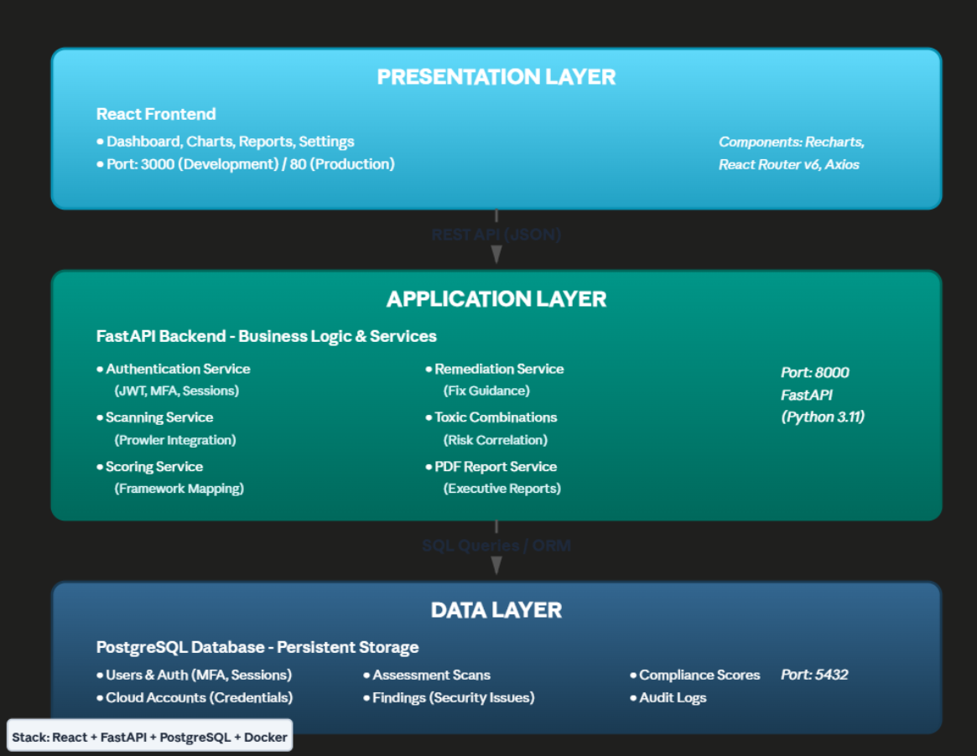

4.4 Database Schema Design
Key Entities:
1. Users - Authentication and authorization
- id (UUID), username, email, hashed_password, mfa_secret, is_active, created_at
2. Cloud Accounts - AWS account management
- id (UUID), account_name, account_id, region, access_key_id (encrypted), secret_access_key (encrypted), created_at
3. AssessmentScans - Scan execution tracking
- id (UUID), account_id (FK), scan_status, started_at, completed_at, total_checks_run
4. ScanFindings - Individual security findings
- id (serial), scan_id (FK), check_id (FK to TechnicalChecks), finding_status (Pass/Fail), risk_level (Critical/High/Medium/Low), resource_id, resource_type, finding_details (JSONB)
5. ComplianceScores - Framework-level scoring
- id (serial), scan_id (FK), framework_id (FK), overall_score (0-100), controls_passed, controls_failed, controls_not_applicable, critical_findings, high_findings, medium_findings, low_findings
6. FrameworkControls - Compliance framework definitions
- id (serial), framework_id (FK), control_id, control_title, control_description
7. ControlCheckMappings - Many-to-many relationships
- Maps technical checks to framework controls (one check can satisfy multiple controls)
8. AuditLogs - Security audit trail
- id (serial), user_id (FK), event_type, event_metadata (JSONB), timestamp, ip_address

4.5 Security Implementation
Authentication & Authorization:
- Bcrypt password hashing (cost factor 12)
- JWT session tokens (15-minute expiration)
- TOTP-based multi-factor authentication (PyOTP)
- Session invalidation on logout
- Secure HTTP-only cookies
Data Protection:
- AWS credentials encrypted at rest (AES-256)
- SQL injection prevention via parameterized queries (SQLAlchemy ORM)
- XSS protection via React's automatic escaping
- CORS configuration for cross-origin security
- Input validation on all API endpoints

Audit & Compliance (future works):
- Comprehensive audit logging of all user actions
- Event types: login, logout, MFA changes, password changes, account management
- Immutable audit trail with timestamps and IP addresses
- Failed login attempt tracking

4.7 Testing Strategy
Unit Testing:
- Backend API endpoints (pytest)
- Database models and relationships
- Authentication service (MFA, password hashing)
- Scoring algorithms
Integration Testing:
- Full scan execution workflow (account → scan → findings → scores)
- Framework mapping accuracy
- PDF report generation
- Toxic combinations detection
Security Testing:
- Authentication bypass attempts
- SQL injection testing (future work)
- XSS vulnerability scanning (future work)
- Session management validation (future work)
- Credential storage encryption verification
User Acceptance Testing:
- Dashboard usability with security professionals
- Report readability with executive stakeholders
- Remediation guidance clarity with DevOps engineers
- Multi-account workflow validation

4.8 Data Collection
Demonstration Data:
To showcase platform capabilities without access to real production AWS accounts, synthetic demonstration data was created:
6 AWS Accounts: Representing different organizational profiles
- AWS Production (large enterprise)
- TechStart Inc (startup)
- SecureBank Financial (regulated industry)
- MidSize Corp (growing business)
- GlobalTech Enterprise (multinational)
- TechStart Inc - AWS Account (duplicate for testing)
- 67-140 Findings per Account**: Realistic distribution of security issues
4 Framework Mappings: Each finding mapped to relevant controls
- CIS AWS Foundations: 40-60 controls per account
- ISO 27001: 35-50 controls per account
- NIST CSF: 30-45 controls per account
- PCI-DSS: 25-40 controls per account

Compliance Scores: Varied to demonstrate different security postures
- Range: 35% - 78% compliance
- Intentional variation across frameworks to show gaps

Synthetic Data Rationale:
Real production AWS scans were not feasible due to:
1. Security restrictions on accessing production cloud environments
2. Cost of maintaining test AWS infrastructure
3. Time constraints of capstone timeline
4. Focus on platform functionality rather than data acquisition
The synthetic data accurately represents real-world Prowler output structure and finding distributions observed in AWS security assessments.

5. CONCEPT AND TOOL USAGE

5.1 What is CSPM?
Cloud Security Posture Management (CSPM) is a category of security tools designed to identify misconfiguration issues and compliance risks in cloud infrastructure. CSPM solutions continuously assess cloud resources against security best practices and regulatory requirements, providing visibility into security posture and automated remediation guidance.
Key CSPM capabilities include:
- Asset Discovery: Identifying all cloud resources and their configurations
- Compliance Assessment: Checking against industry frameworks (CIS, ISO, NIST, PCI)
- Misconfiguration Detection: Finding security weaknesses (open ports, public buckets, weak IAM)
- Risk Prioritization: Scoring findings by severity and business impact
- Remediation Automation: Providing fixes or automatically correcting issues
- Continuous Monitoring: Real-time assessment as infrastructure changes

5.2 The Need for CSPM Tools
Why Organizations Need CSPM:
1. Cloud Complexity: Modern cloud environments contain thousands of resources with millions of configuration options. Manual review is impossible on a scale.
2. Shared Responsibility Model: Cloud providers secure infrastructure (physical servers, networks), but customers are responsible for securing their configurations (IAM policies, security groups, encryption). CSPM helps customers fulfill this responsibility.
3. Compliance Requirements: Regulations like GDPR, HIPAA, PCI-DSS require documented evidence of security controls. CSPM automates compliance checking and report generation.
4. DevOps Speed: Infrastructure changes happen continuously through automated CI/CD pipelines. Security must keep pace without slowing development. CSPM provides fast, automated security validation.
5. Skills Shortage: Security teams lack bandwidth to manually review thousands of configurations. CSPM augments limited human resources with automation.
6. Breach Prevention: 95% of cloud breaches result from misconfiguration (Gartner 2023). CSPM identifies these issues before exploitation.

5.3 Platform Use Cases
Primary Users:
1. Security Operations Teams
- Monitor compliance posture across all AWS accounts
- Investigate security incidents and audit trails
- Generate evidence for compliance audits
- Track remediation progress
2. Cloud Engineers / DevOps
- Receive specific remediation guidance (AWS CLI, Terraform)
- Understand security implications of infrastructure changes
- Fix findings before production deployment
- Maintain infrastructure-as-code security
3. Compliance Officers
- Generate executive reports for audit committees
- Track compliance metrics across frameworks
- Document remediation timelines
- Provide evidence to external auditors
4. Executive Leadership
- Understand organization's security posture at a glance
- Prioritize security investments based on risk scores
- Compare compliance across business units
- Demonstrate due diligence to board of directors

Typical Workflow:
1. Setup: Add AWS accounts with appropriate IAM credentials
2. Scan: Execute automated Prowler security assessment
3. Analyze: Review findings dashboard and toxic combinations
4. Prioritize: Focus on highest-risk attack paths first
5. Remediate: Use provided AWS CLI/Terraform to fix issues
6. Verify: Re-scan to confirm fixes resolved findings
7. Report: Generate PDF executive report for stakeholders
8. Monitor: Schedule periodic scans to detect configuration drift

5.4 Key Platform Features
1. Multi-Account Support
Manage security across entire AWS organization from single dashboard. View compliance scores, compare findings, and track remediation across 5+ accounts simultaneously.
2. Four-Framework Compliance
Simultaneous assessment against CIS AWS Foundations, ISO 27001, NIST Cybersecurity Framework, and PCI-DSS. Single finding automatically mapped to relevant controls across all frameworks.
3. Toxic Combinations Detection
Novel risk correlation engine identifies how multiple moderate-severity findings combine into critical attack paths. Example: "CloudTrail disabled + Root account without hardware MFA = undetected account takeover (Risk Score: 85)."
4. Actionable Remediation Hub
For 15+ common security checks, provides three remediation options:
- Copy-paste AWS CLI commands with resource IDs auto-populated
- Terraform configuration for infrastructure-as-code
- Step-by-step manual procedures
5. Recurring Findings Analysis
Identifies security issues that persist across multiple scans, indicating systemic problems or insufficient remediation processes. Tracks occurrence count, first seen date, and days persistent.
6. Executive PDF Reports
Auto-generated 6-page compliance reports with:
- Executive summary with business risk context
- Compliance trends over time
- Framework performance comparison
- Strategic remediation recommendations
- Estimated costs and timelines
7. Security & Audit
- Multi-factor authentication (TOTP)
- Comprehensive audit logging
- User settings management
- Session security

5.5 Platform Screenshots
Log in and Authentication:
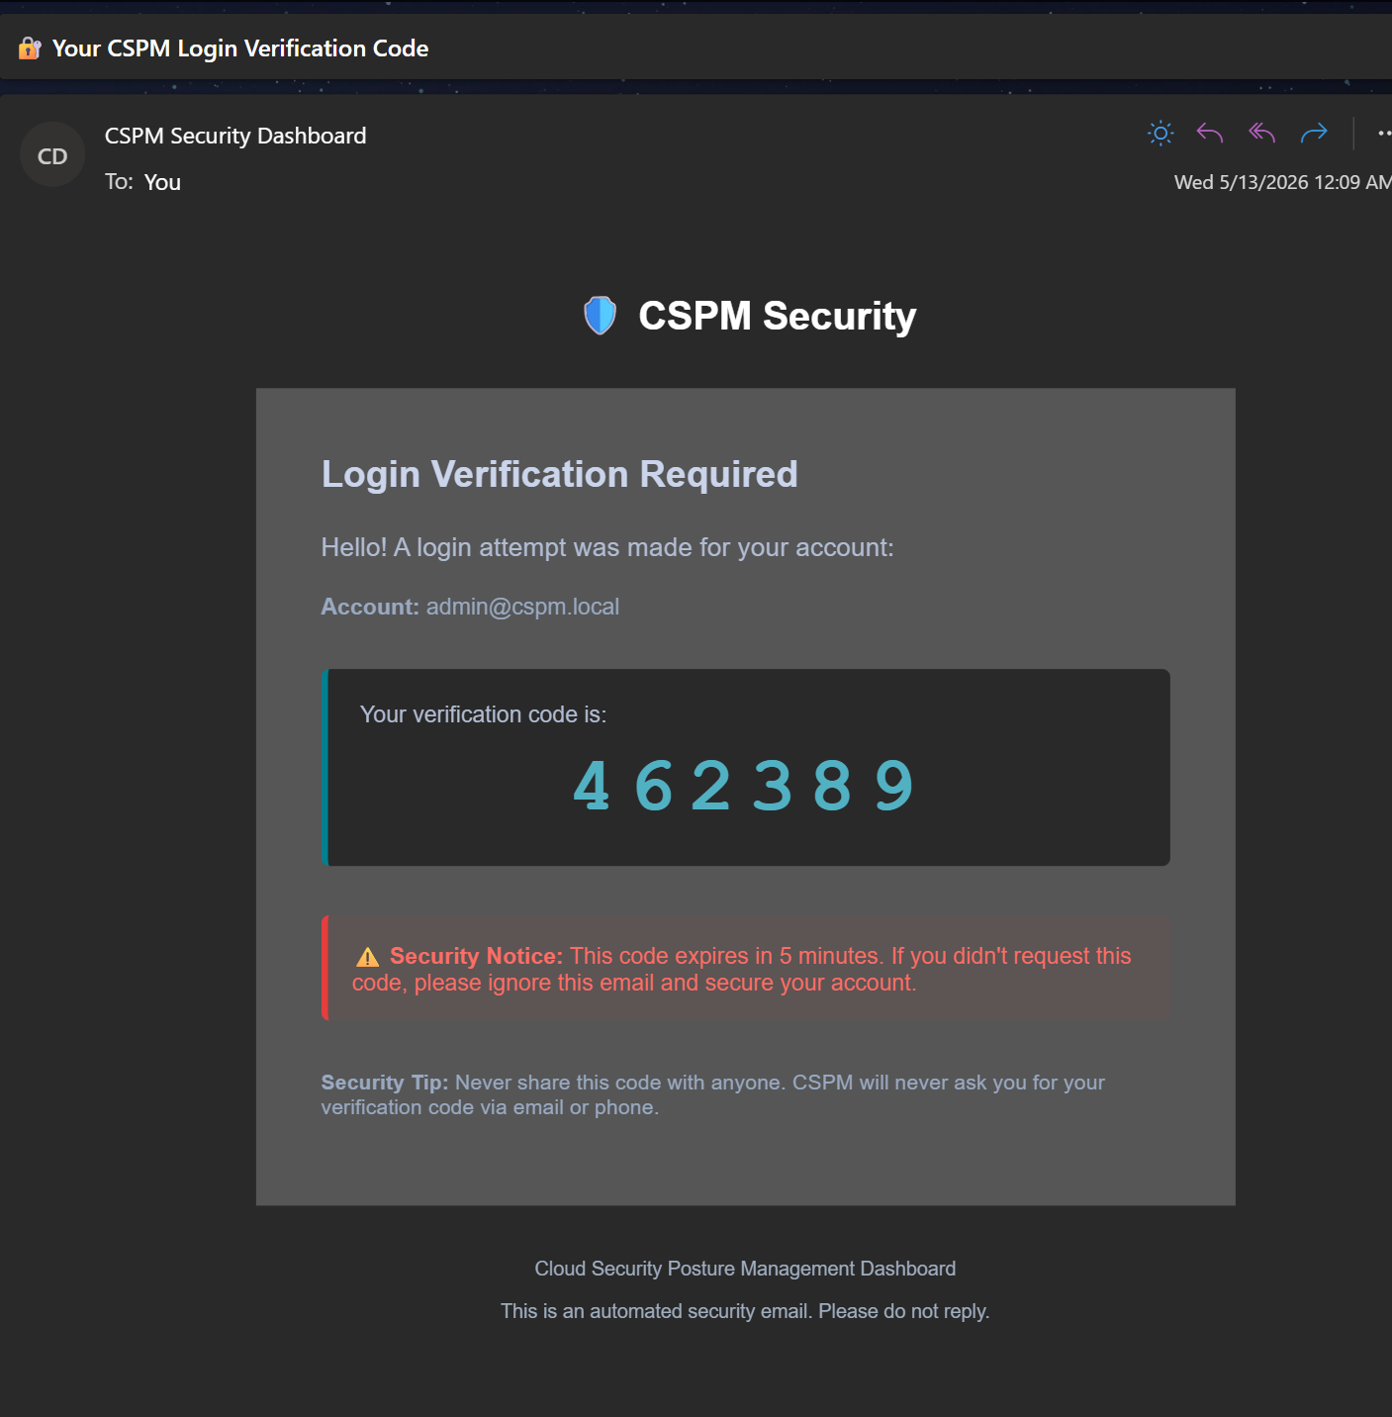

Dashboard Overview:
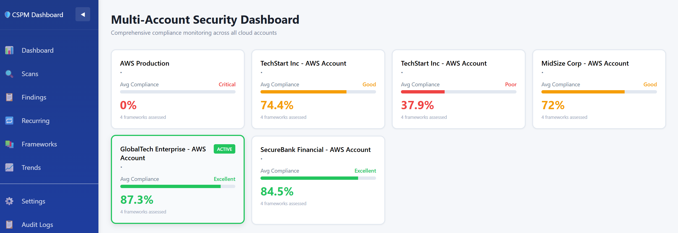
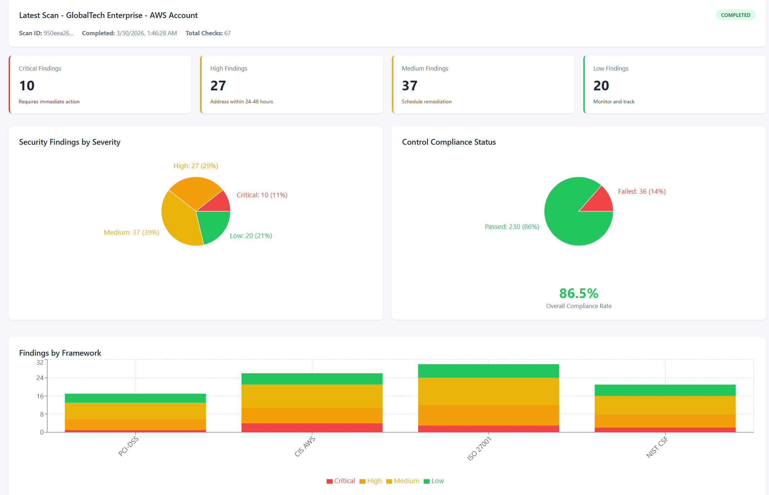
Dashboard showing compliance scores across 4 frameworks with risk summary cards and trend charts

Toxic Combinations Detection:
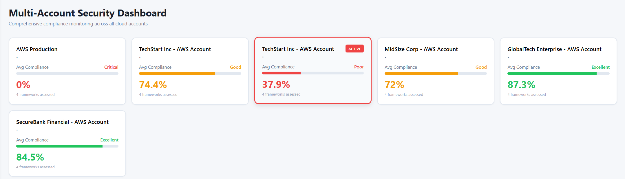
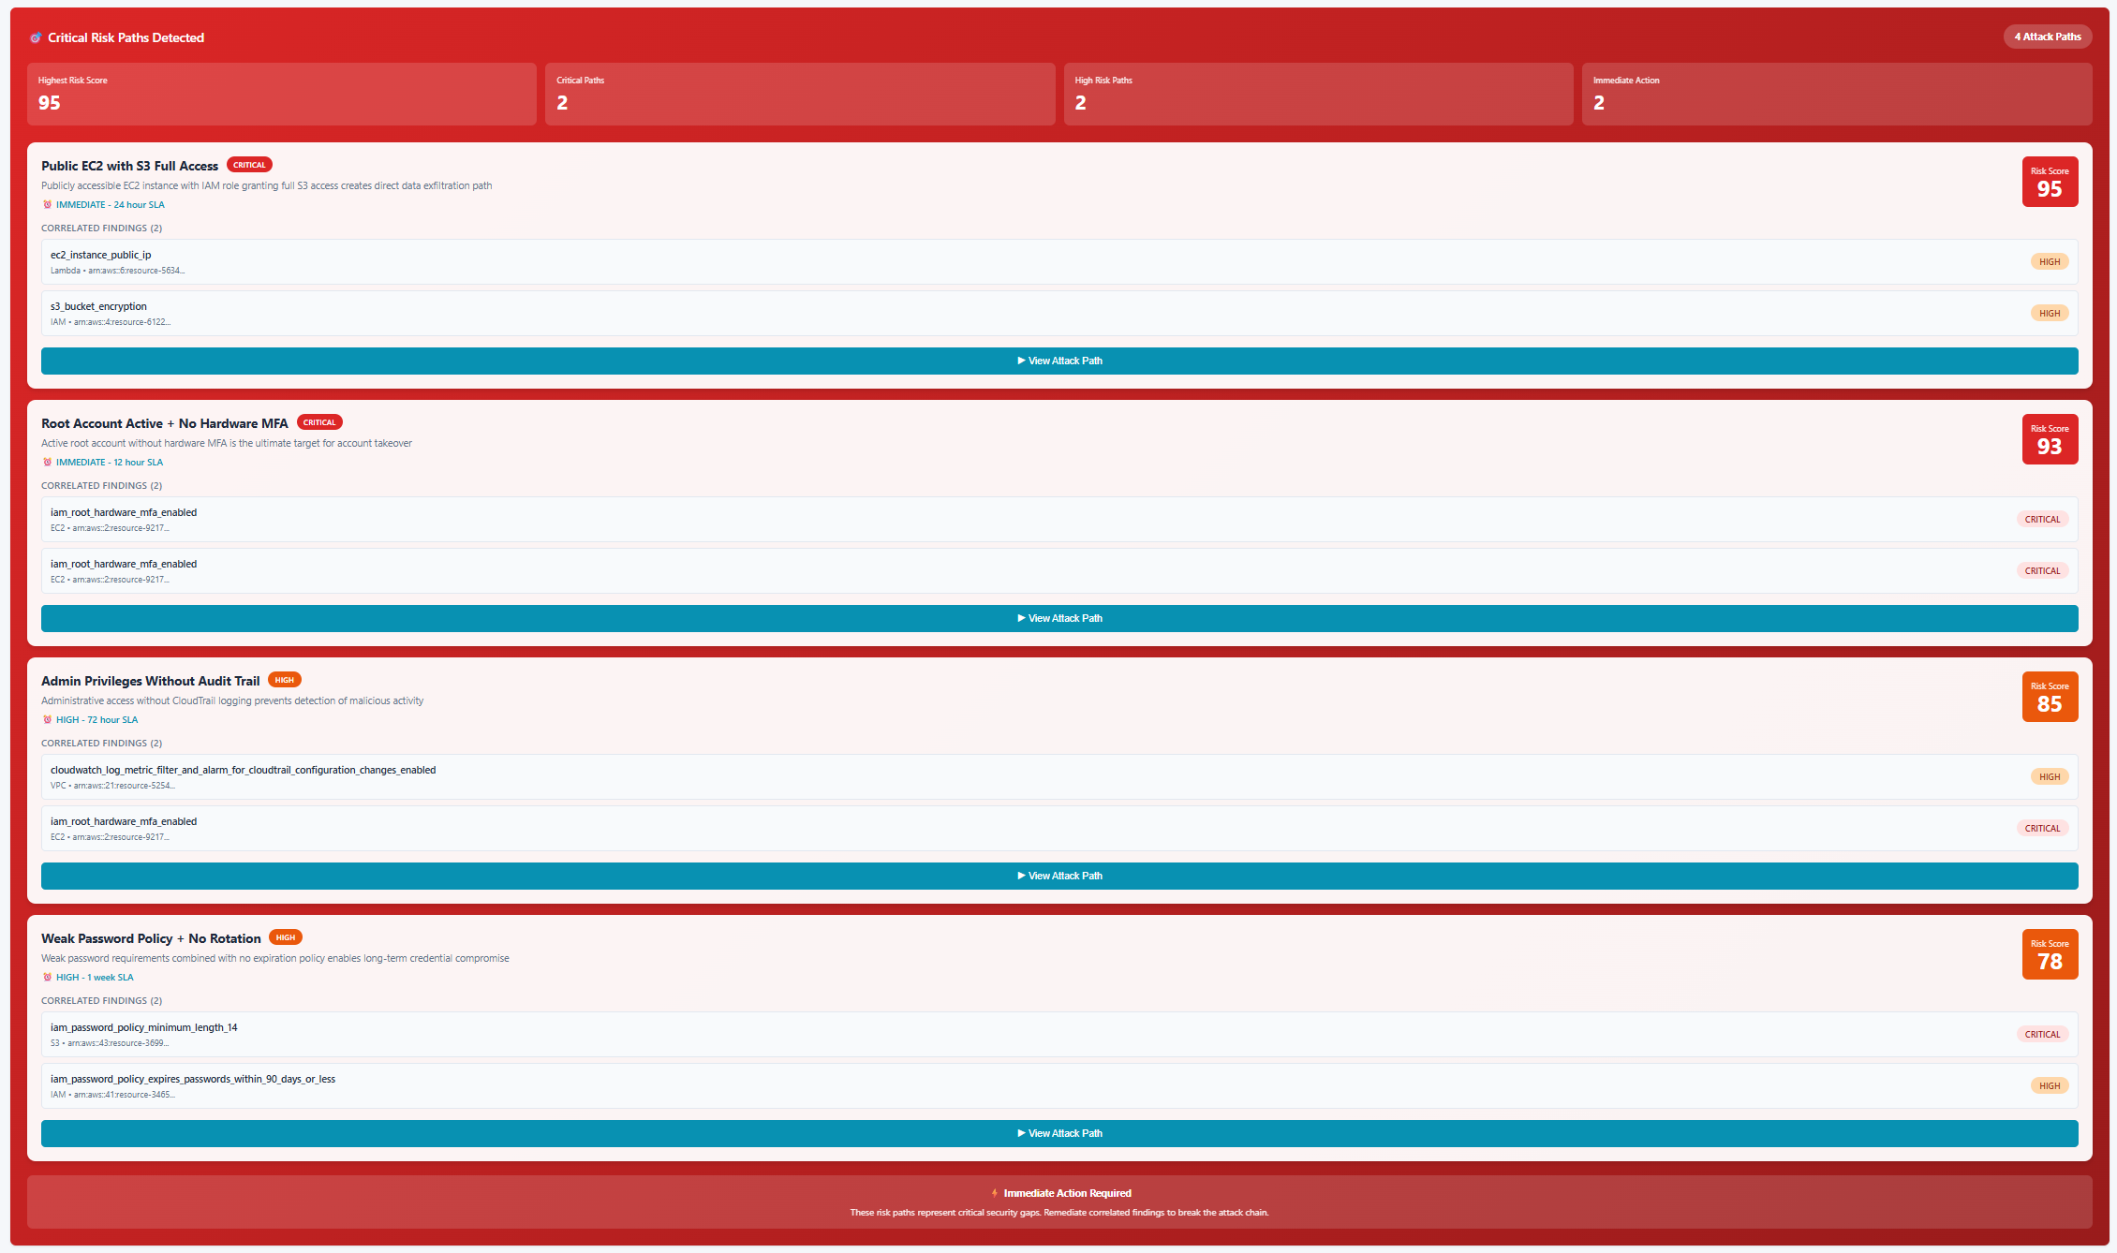
Red alert card showing "4 Attack Paths Detected" with risk scores and expandable attack chain visualization. This screenshot depicts that of a start-up TechStart Inc.
Findings Analysis:
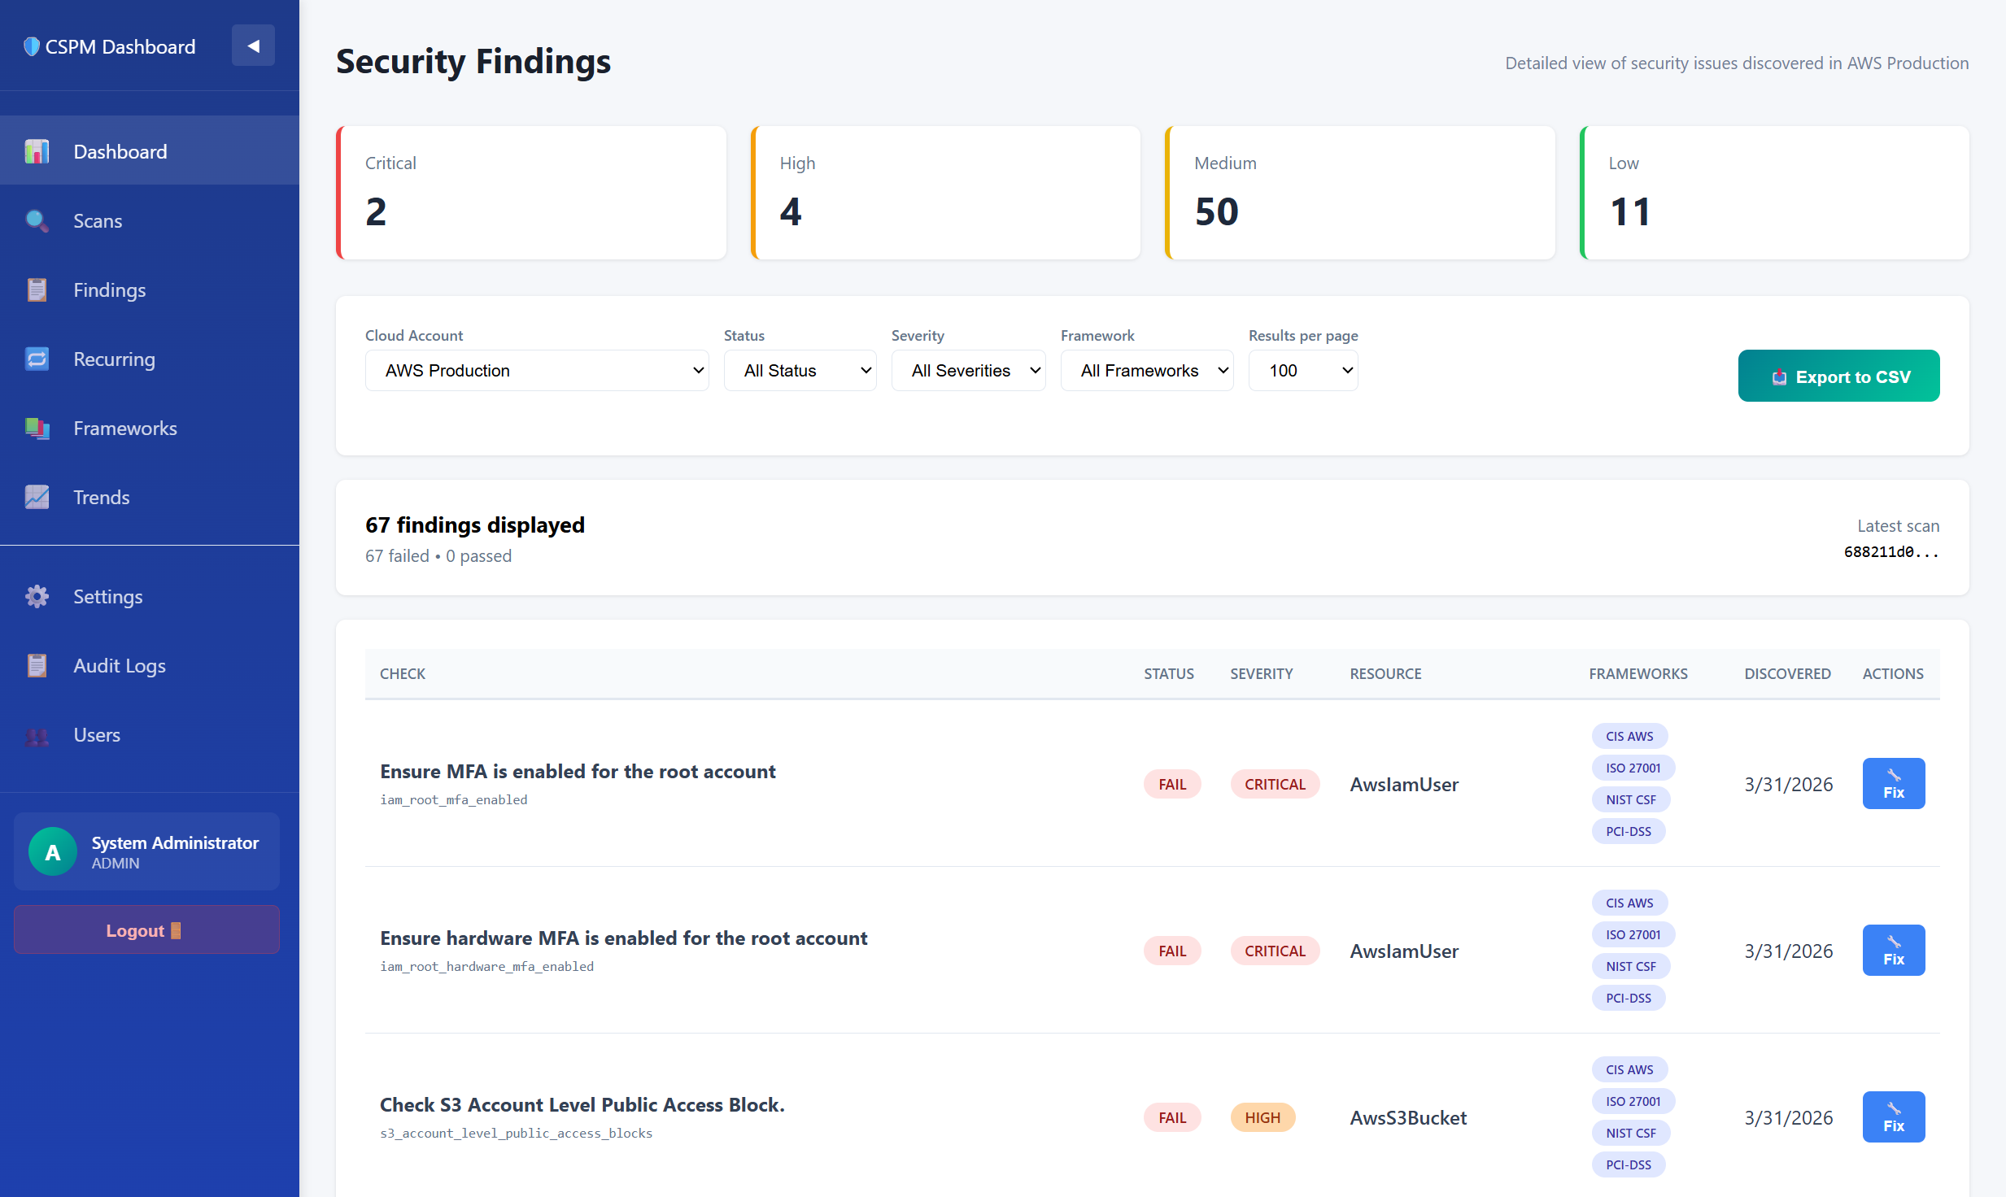
Filterable table of security findings with severity badges, framework mappings, and Fix buttons

Remediation Modal:
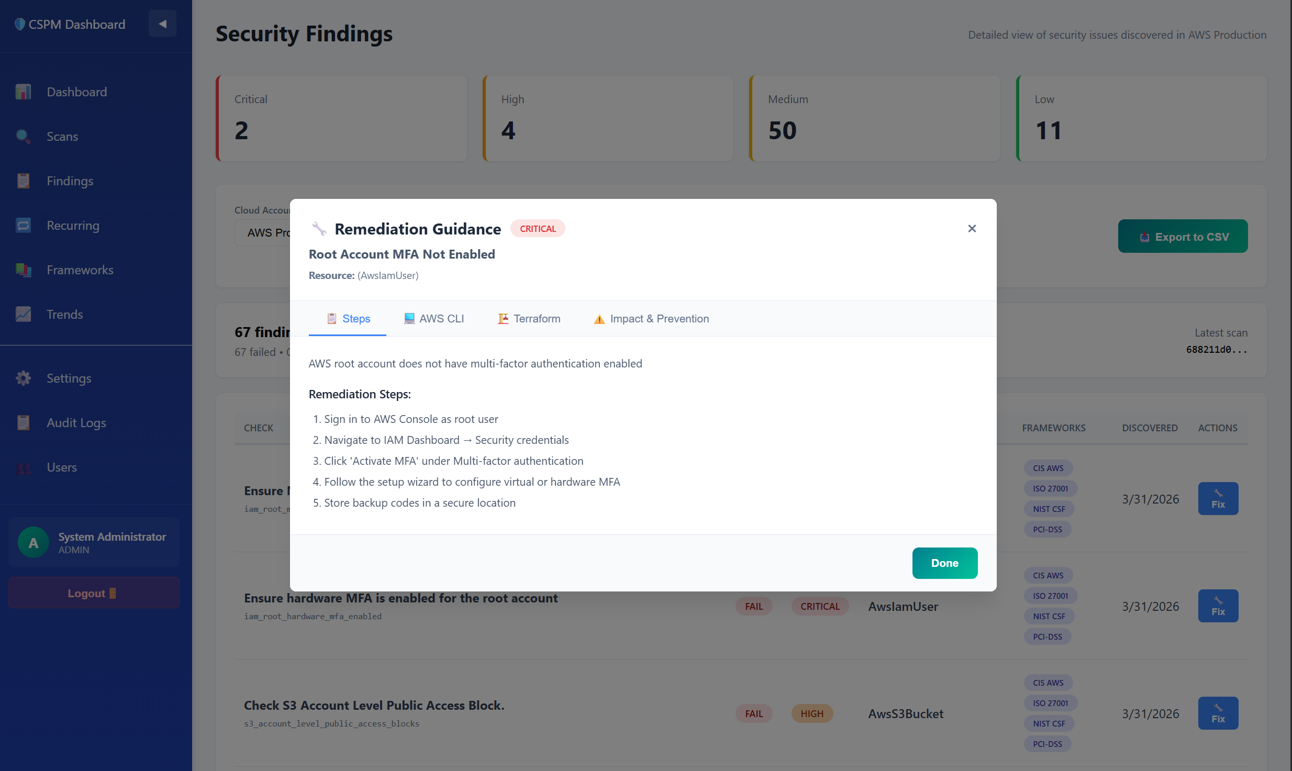
4-tab modal showing remediation steps, AWS CLI commands, Terraform code, and impact analysis
Executive PDF Report:
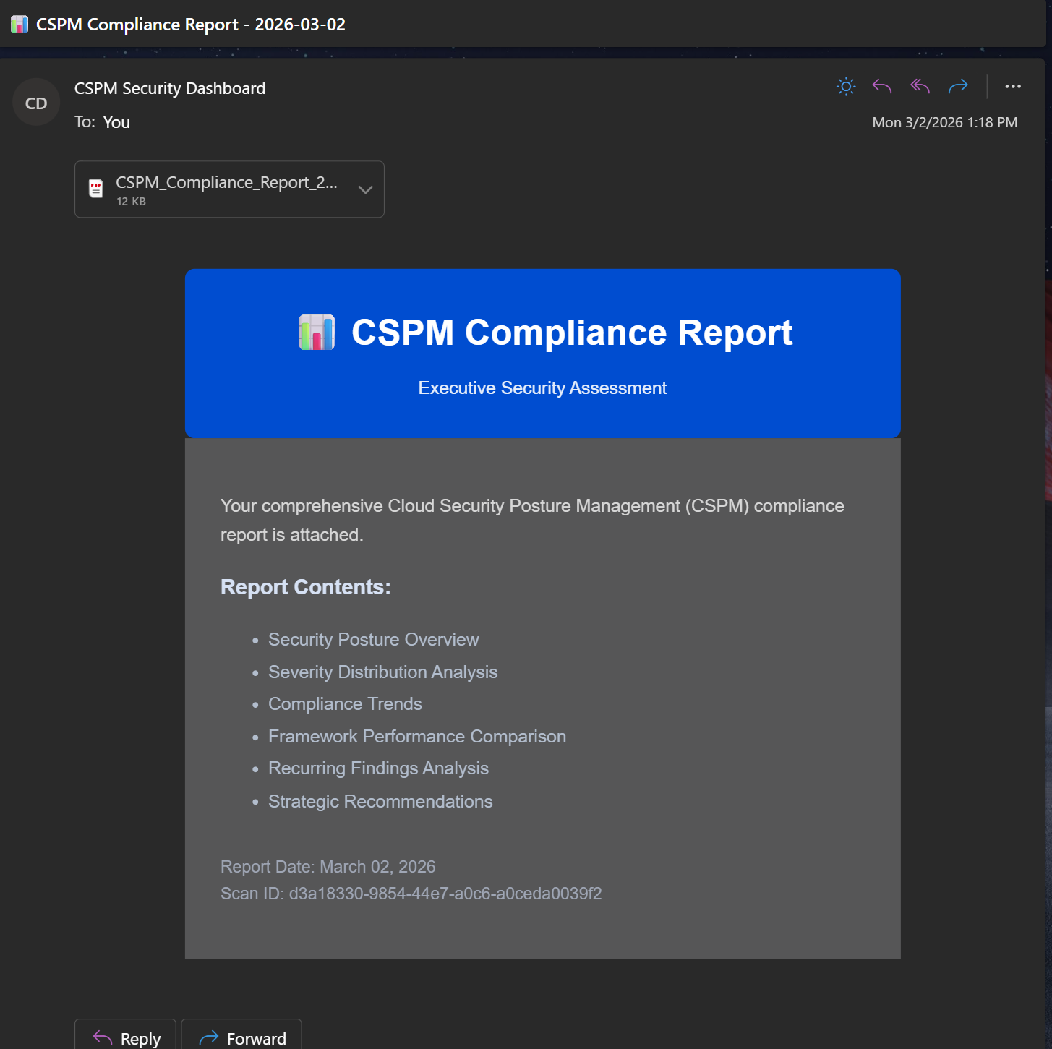
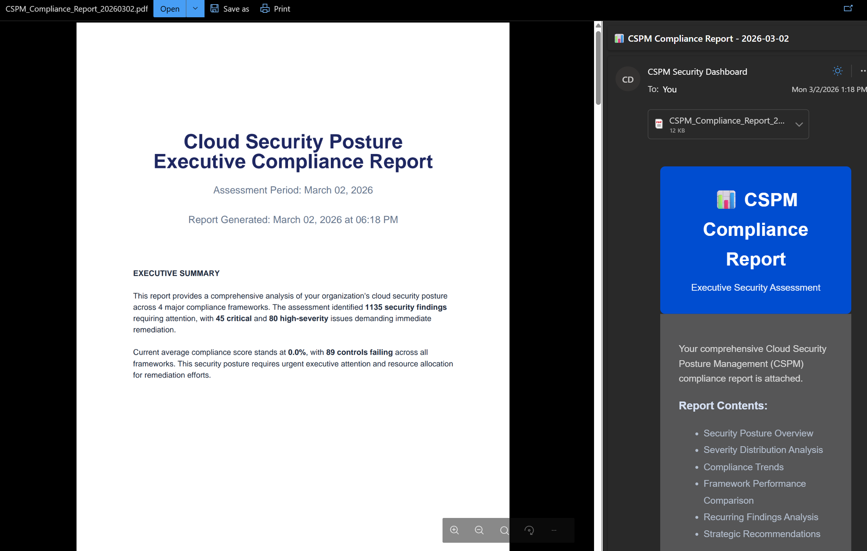
6-page PDF with charts, insights, and strategic recommendations

6. CHALLENGES AND LIMITATIONS

6.1 Technical Challenges
1. Framework Control Mapping Complexity
- Challenge: Mapping 300+ Prowler checks to 200+ controls across 4 frameworks
- Solution: Created normalized technical_checks and framework_controls tables with many-to-many control_check_mappings
- Lesson: Database design critical for handling complex many-to-many relationships
2. Synthetic Data Generation
- Challenge: Creating realistic demonstration data without real AWS access
- Solution: Analyzed real Prowler output structure, generated statistically representative findings with varied severities and resource types
- Limitation: Cannot validate against real-world AWS infrastructure behaviors
3. Toxic Combinations Pattern Tuning
- Challenge: Balancing pattern specificity (too narrow = misses attacks) vs. generality (too broad = false positives)
- Solution: Implemented regex-based check matching with minimum severity thresholds
- Future Work: Machine learning could discover patterns from historical data
4. Performance at Scale
- Challenge: Database queries for findings with framework mappings become slow with thousands of findings
- Solution: Added database indexes on scan_id, check_id, framework_id; used SQL aggregation instead of application-level processing
- Future Work: Implement caching layer for frequently accessed data

6.2 Scope Limitations
1. Single Cloud Provider
- Current: AWS-only (Prowler limitation)
- Future: Extend to Azure, GCP using ScoutSuite or custom scanners
2. Limited Remediation Coverage
- Current: 15 checks with detailed guidance (22% coverage)
- Future: Expand to 50+ checks, add automated fix execution
3. No Real-Time Monitoring
- Current: Periodic scan-based assessment
- Future: CloudWatch Events integration for real-time drift detection
4. Basic Risk Scoring
- Current: Rule-based risk scores (static patterns)
- Future: ML-based dynamic scoring considering context, exploit probability, asset value.

6.3 Research Limitations
1. Demonstration Data
- Synthetic data may not capture real-world AWS complexity
- No validation against production security incidents
- Compliance scores manually varied rather than calculated from real infrastructure
2. Pattern Validation
- Toxic combination patterns based on security best practices, not empirical breach data
- No quantitative validation of false positive/negative rates
- Limited security expert review of pattern accuracy
3. Generalizability
- Designed for AWS; patterns may not transfer to other clouds
- Focused on configuration issues; doesn't address runtime threats, application vulnerabilities
- Assumes organizations use standard compliance frameworks

7. CONCLUSION
This capstone project successfully demonstrates that cloud security assessment can evolve beyond simple checklist compliance to provide intelligent, context-aware risk analysis. By implementing toxic combinations detection the platform identifies critical attack paths that individual findings would miss.
Key Achievements:
1. Production-Grade Implementation: Full-stack application with authentication, database design, API architecture, and responsive UI
2. Multi-Framework Intelligence: Simultaneous compliance assessment across CIS, ISO, NIST, PCI with unified scoring
3. Novel Risk Correlation: 10 attack patterns detecting how moderate issues combine into critical threats (Risk Scores 76-95)
4. Actionable Guidance: Specific remediation with AWS CLI, Terraform, and manual procedures for 15 common checks
5. Executive Communication: Auto-generated PDF reports translating technical findings to business risk
Research Contribution:
This work bridges the gap between compliance automation and security intelligence, demonstrating that:
- Correlated findings represent greater risk than isolated issues
- Risk prioritization must consider attack paths, not just individual severity
- Effective remediation requires specific, executable guidance, not generic advice
- Security tools should communicate in both technical and business languages
Future Impact:
The platform's modular architecture and toxic combinations engine provide a foundation for advanced research in ML-based attack prediction, automated remediation orchestration, and multi-cloud risk analysis. As organizations increasingly adopt cloud infrastructure, tools that provide intelligent, prioritized, and actionable security guidance will become critical to managing complex, dynamic environments.

8. REFERENCES
1. Gartner. (2023). "Forecast: Public Cloud Services, Worldwide, 2021-2027." Gartner Research.
2. MarketsandMarkets. (2023). "Cloud Security Market - Global Forecast to 2028." Market Research Report.
3. IBM Security. (2023). "Cost of a Data Breach Report 2023." IBM Corporation.
4. (ISC)². (2023). "Cybersecurity Workforce Study 2023." International Information System Security Certification Consortium.

